Efficient word searching using Trie Data Structure

Divya Lambhate | Aditya Magdum
Department of Computer Technology | Department of Computer Technology
Pune Institute of Computer Technology | Pune Institute of Computer Technology
Pune, India. | Pune, India.
divya19lam@gmail.com | magdumadiraj@gmail.com

Abstract - The data can be accessed quickly for processing when it is organized efficiently on the storage device and on the main memory. It will reduce the access time and will provide better working environment to the users. In case of huge data/files/documents, using simple algorithms and searching techniques for word search proves to be inefficient and increases the time complexity. To reduce the time complexity for string searching algorithms, we propose to implement fast trie data structure. Given a set of N records whose keys are distinct nonnegative integers less than some initially specified bound M, a trie will use space O(N) and time O(M) for insertions, deletions, and all the retrieval operations commonly associated with binary trees. A trie is implemented by locating specific keys from within a set. These keys forms links between nodes defined by individual characters. Each trie node consists of an array of pointers where every index of an array represents a character. The trie traverses by depth-first in order to access a key. If two strings have the same prefix then they will have the same ancestor in the trie. This will make searching easier. In this way the trie data structure is used for faster word searching.

Index Terms – Trie, Algorithms.

I. Introduction
Fast data retrieval applications such as web search engines, data mining tools, object relational databases, rule based expert systems, AI planning systems and internet applications require data structure with minimum time complexity. Linear data structures like arrays and linked lists is inefficient for large set of data as traversal includes comparison with every data entry. In some cases, the non-linear data structure such as skewed binary tree fail to provide faster searching which is need of rapidly growing world.
Therefore for advanced and fast searching we are making use of the trie data structure. Trie is a type of k-ary tree (node has no more than m children). It is used find strings in the form of keys in a specific set. To perform operations on a key trie traverses through depth first. All the children of a node have a common prefix of the string associated with that parent node, and the root is associated with the empty string.
Tries are composed of that contain links that are either references to other child suffix child nodes or null. Except for root, each node is pointed to by just one other node, called the parent. Trie follows some property that if two strings have common prefix then they will have the same ancestor in the trie. Each node represents a string and each edge represents a character. Each node consist of an array of pointers of length 26 (the alphabet). Each path from the root to any node represents a word or string. Every trie node consists of a character pointer array and a flag to represent if the word is ending at that node or not. But if the words contain only lower case letters then we can define trie node with an array instead of a hashmap.
For word searching problems, firstly the data will be stored in the tree using the insert operation and then the word to be searched will be searched by the trie data structure using the search operation through prefix searching and depth first searching. Because of the prefix searching, less time would be taken up as the words not matching with the prefix of the word to be searched would not be further searched for, thus efficiently conducting this operation.
Thus this trie data structure being a very efficient and optimised way for word searching would be implemented for the same.

II. Body of article
1). Implementation
To implement the trie data structure, the two main operations performed on it will be the inserting of the data and the searching; the searching being the main topic of this project. This data structure is made of nodes that has links, which are either linked to other suffix child nodes or null values. Each node will have M links which is the set of alphabets. A basic structure type of nodes is shown below-
structure node
Child node [alphabetsize]
Is-terminal Boolean
Value Data-Type
end structure

The following figure shows how a trie data structure looks like:

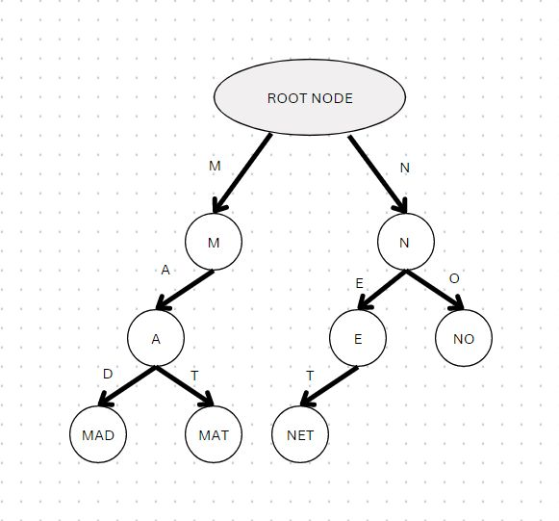

Fig. (A)

In order to implement the searching, we need to first insert the data into the data structure.

- Insertion
To input a key into the trie, each character of the key will be inserted as an individual node. The children of the node is an array of pointers and the character of the key would act as the index of the children array. If there is a new input key or an extension of an existing key, construct non existing nodes of key, and mark end of the word for the last node. The length of the key would determine the depth of the trie. The root consists of an empty string and 26 pointers each initialized with NULL. N in the diagram represents a NULL value at every index. Now let us try to insert the string ‘MAD’ in the Trie. The root node was created. Every index of the childNode pointer array is NULL. The current node initially will be the root node. The first character of the input string is t. In the root node, we will check whether the t-a th index of the childNode array is NULL or not. As the t-a th index of the childNode array is NULL. We make a new TrieNode with help of the constructor defined in the structure of the TrieNode. We will point the m-a th index of the childNode pointer array of the root node to the new node created. We will make the new node created as the current node and proceed to the next step. As string m is not the end of the string tea we will not increment the wordEndCnt variable for the current node or the new node created in step 1.Since the string mad is the end of the string mad we will increment the wordEndCnt value for this node.

The following figure shows the insertion of the key into the trie:
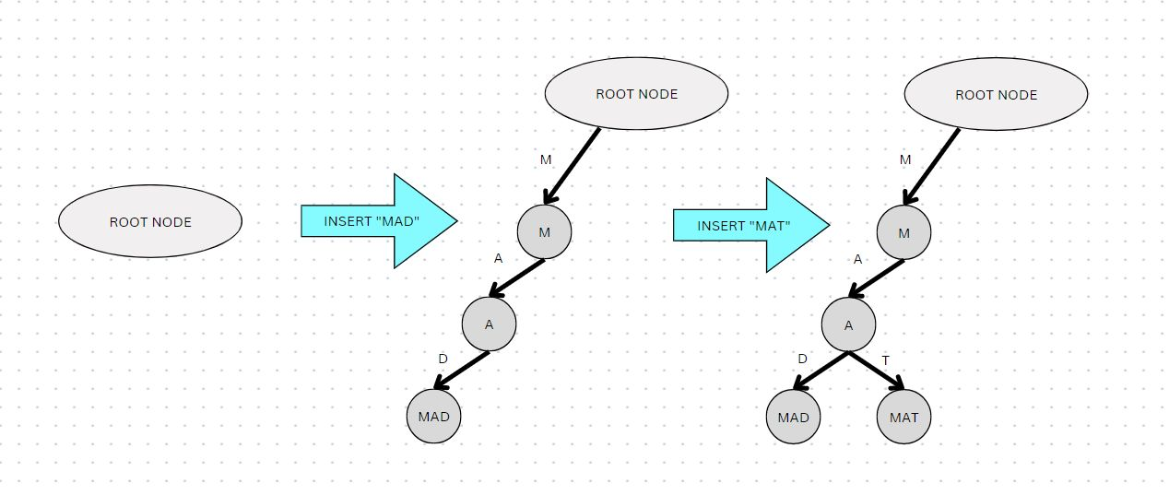

- Searching
This is similar to the insert operation but it only compares and moves to the next child node. The search terminates after the end of the string. This happens if theEndofWord field of the last node is true, then the key will exist in the trie. We will search the word ‘NET’ in the trie. Initially, the current node is the root node. The first character of the query string is t. We check whether the t-a th index of the childNode pointer array of the current node is NULL or not. As it is not null we move the current node pointer to the node pointed by t-a th index of the current node which is the root node in step 1. Finally, we check if the wordEndCnt for the current node is greater than 0 or not. If the wordEndCnt is greater than 0 which is the case for the query string net we return true. Otherwise, we return false.

Following is the figure to represent the searching operation:
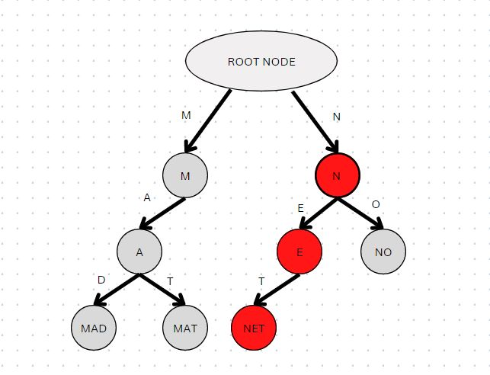
Fig. (C)

To implement this data structure, we first need to create a node then store a collection of strings that have to be inserted in the trie then insert all strings and then the search operation would take place.

Complexity analysis of the trie data structure:
Time Complexity: O(n)
Space Complexity: O(1)
Thus we successfully implement the search operation efficiently.

III. Limitations

The trie data structure takes up a lot of memory to store the data. There are too many node pointers for each node that are equal to the number of characters in the worst case. If we construct an efficient hash table it would take up O(1) time whereas the trie data structure would take up O(n) time where n is the length of the key.

IV. Future Scope

Because of the less time taken by the trie data structure to perform the search operation, it is very useful for word searching, prefix searching, autocorrect and spellcheck. It can be used at many places such as pdf and document searching, web browsing and many more places. In today’s world, where time is of utmost importance, this data structure would prove to be beneficial in the upcoming days.

V. Conclusion

Despite a huge number of data to be processed for searching, the number of comparisons that take place to search a desired string will always be equal to the length of the string which is very efficient. There is no need to search from the entire number of strings present in the data structure because the trie data structure will only look through the common prefixes which matches the word to be searched and not touch the remaining words. Thus it is a very efficient way to search a desired word through this trie data structure. This trie data structure has many applications and is very beneficial in modern applications. Therefore we successfully implemented the trie data structure for efficient word searching.

VI. Acknowledgements

I would like to acknowledge and give my warmest thanks to my supervisor and STC guide Mr. Satyaprakash Patel who made this work possible. His guidance and advice carried me through all the stages of writing my research paper. I am also grateful to all of my fellow teammates with whom have successfully carried out this project.

VII. References

[1] Kang G.Shin, “Granularity of trie based data structure for name lookups and updates,” IEEE Vol.27 (2019).

[2] IZTOK Savnik,Mikita akulch “Data structure set-trie for storing and querying sets”(2021)

[3] HAMED YOUSEF,” A fast and memory efficient trie structure for name based packet forwarding” (2018)

[4] Richard H. Connelly, F.Lockwood Morris, “A generalization of the trie data structure” Cambridge University Press (2009).

[5] T. Kijkanjanarat, H.J. Chao, “Fast IP lookups using two trie data structure”, IEEE Explore(2002)

[6] Nikolas Askitis, Ranjan Sinha, “Trie: A cache conscious trie based data structure for strings” Australian Conference (2007).

